Supplementary Material
Gencrypt: One-way cryptographic hashes to detect overlapping individuals across samples
Turchin, M.C.^{1,2} and Hirschhorn, J.N.^{1,2,3,*}
¹Divisions of Endocrinology and Genetics, Children’s Hospital Boston, Boston, Massachusetts 02115 USA
²Broad Institute, Cambridge, Massachusetts 02140 USA
³Department of Genetics, Harvard Medical School, Boston, Massachusetts 02115 USA
* To whom correspondence should be sent: joelh@broadinstitute.org

Content:
- Supplementary Figure 1
- Supplementary Figure 2

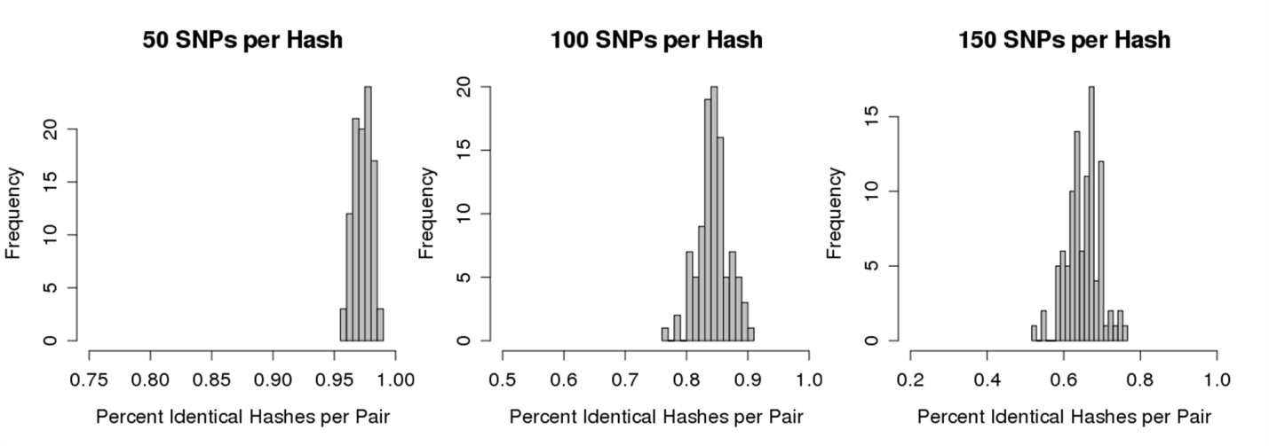
Supplementary Figure 1. Distributions of percent identical hashes from Maywood-derived dataset. Shown in gray are the distributions of percent identical hashes produced between every pair compared from the 743 person Maywood-derived dataset (missingness per individual = ~1%). Distributions are shown for hash outputs based on SNP grouping sizes of 50, 100 and 150 SNPs. Only the 100 duplicate pairs produced any identical hashes; no other pairs of individuals produced a single, overlapping hash. Percentages ranged from ~50% to ~100% across SNP groupings shown.

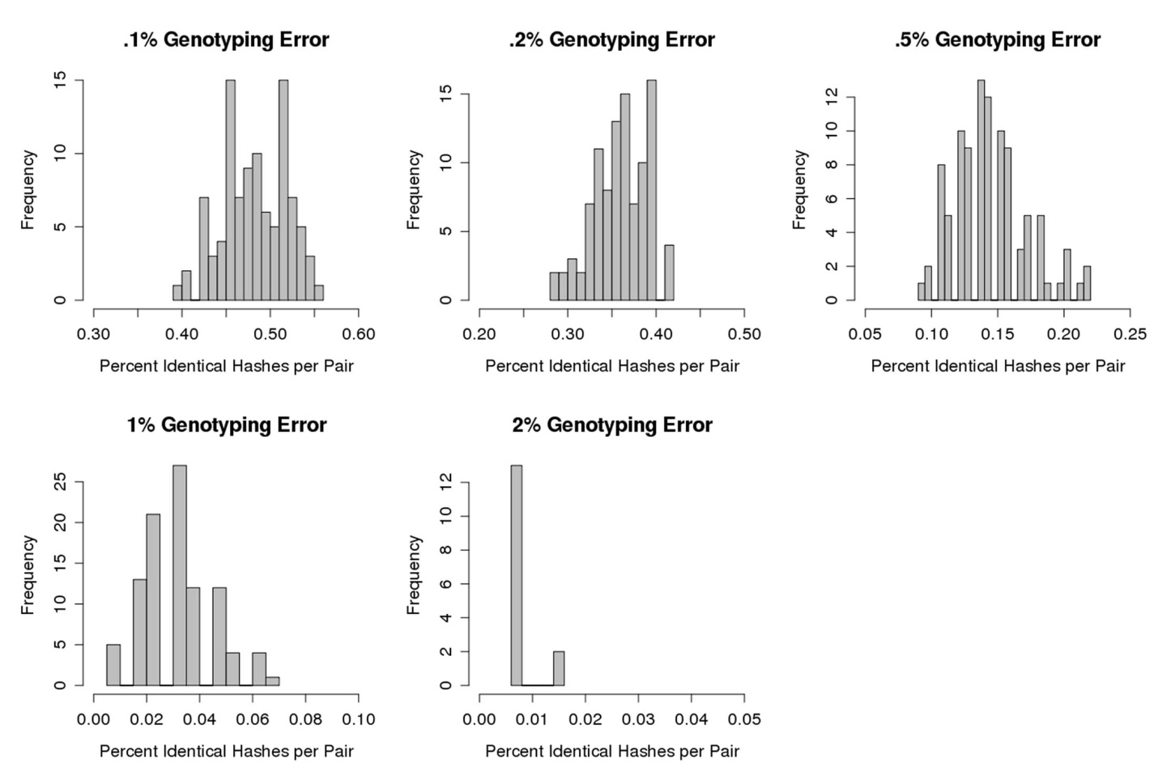
Supplementary Figure 2. Distributions of percent identical hashes in the presence of genotyping error. Shown in gray are the distributions of percent identical hashes from Supplementary Figure 1, using 150 SNPs per hash, but with varying levels of genotyping error introduced. Genotyping error rates tested were .1%, .2%, .5%, 1% and 2%. Gencrypt identified all 100 duplicate pairs at genotyping error levels of .1%, .2% and .5% (realistic levels of genotyping error), 99 duplicate pairs at a genotyping error level of 1% and 15 duplicate pairs at a genotyping error level of 2%. Number of identical hashes found per duplicate pair progressively decreased as genotyping error rate increased.

